

User Guide

Inventory Management System

Group: DBIT/FT/3B/83

Supervisor: Mr. Tan Chee Siong

|  |  |
| --- | --- |
| Name | Admin Number |
| Lee Chern Chow | 1114382 |
| Hnin Inzale | 1212152 |
| Tchea Jia Wei | 1212491 |
| Vanessa Tan Wen Qi | 1212714 |
| Rebecca Goh Kai Yen | 1216664 |

About this Guide

The user guide for the Inventory Management System is for administrators and users of our client. The client in this context refers to Lian Fuat Motor Works Sdn. Bhd.

The following related documents for the Inventory Management System are available:

* User Guide, which describes all the functions and features available on the system
* Technical Bulletins, which describe workarounds to existing issues

Table of Contents

Introduction 5

Background Information 5

About our system 5

About the Application 6

Business Activities 6

Purchase Order 6

Job Order/ Quotation 6

Sales Invoice 6

Function Hierarchy Diagram 7

Summary of Functions 8

Sales 8

Inventory 9

Report 9

Operating Environment 10

Hardware 10

Software 10

Procedure for configuring server 10

General Procedures & Information 11

Sign-on and Sign-off procedure 11

Operating Instructions 11

Function Documentation 12

Getting started 12

Logging into system 12

Home Page 13

Sales 14

Create a quotation 15

Creating New Customer 15

View Existing Customer 15

Create an Invoice 16

View an Invoice 16

Receive Payment 16

Inventory 17

Create new supplier item 18

Supplier Creation and View 19

New purchase order 20

A/P Payment 20

Report 21

Sales Graph 21

Sales Graph 22

Complete list of test data 24

# Introduction

This User Manual contains all the necessary information for the users to make full use of our web-based Inventory and Invoicing System, developed by the Team Sunshine. The aim of this user’s manual is to provide useful information on how to use our web-based Inventory and Invoicing System effectively. This user’s manual serves as an aid for all the users who will be using this system. This manual includes a description of the system functions and capabilities, contingencies and alternate modes of operation, and step-by-step procedures for system access and use. Moreover, this user manual also provides the detail information on system’s functions to aid the understanding of our software system.

## Background Information

This system consists of three important features such as Sales, Inventory and Report. This system is to help our client have smoother transactions as it provides all the necessary functions that our client is needed. This system is implemented and altered to suit the needs of our client. Thus, this system plays an important role in daily transactions.

The purpose of this user manual is to provide necessary information on how to operate our inventory and invoicing system efficiently. This user manual is to aid the understanding of a system and also to help out all the admin employees of our client. Also, it is aimed to serve as a guide line throughout our system.

## About our system

This software system is a web-based inventory and invoicing system and it specialised and altered to suit the needs of our client Lian Fuat Motor Works Sdn Bhd. It is a web-based, and is able to operate on any machines that has a web browser.

# About the Application

## Business Activities

### Purchase Order

A purchase order is a formal request/instruction send from a purchasing organization to a vendor to supply a certain quantity of goods or services at or by a certain point in time. For example, our client order 10 cartons of engine oil from Castrol. Thanks to our system, purchase order can be created in our system under the inventory section. Created purchase order will be sent to our supplier, Castrol after confirming the parts that our client wants to order. Supplier will be able to receive the purchase order sent by our system. The transaction between our client and Castrol will be easier in future due to PO History.

### Job Order/ Quotation

A quotation presents the customer with a legally binding offer for providing services within defined fixed conditions. Within a specified time period, this offer is legally binding for the company. A sales area can reply to a customer inquiry with a customer quotation. Job order can be created in our system. Job order is created every transaction that our client is made. Job order serves as information sheet between our client and its customers.

### Sales Invoice

The customer is billed for the relevant order after receiving the invoice for the order. Sale invoice can be created under Sales Section. Sale Invoice is billed to customer every time repair is done. Sales invoice serves as billing document to all the customers of our client.

## Function Hierarchy Diagram

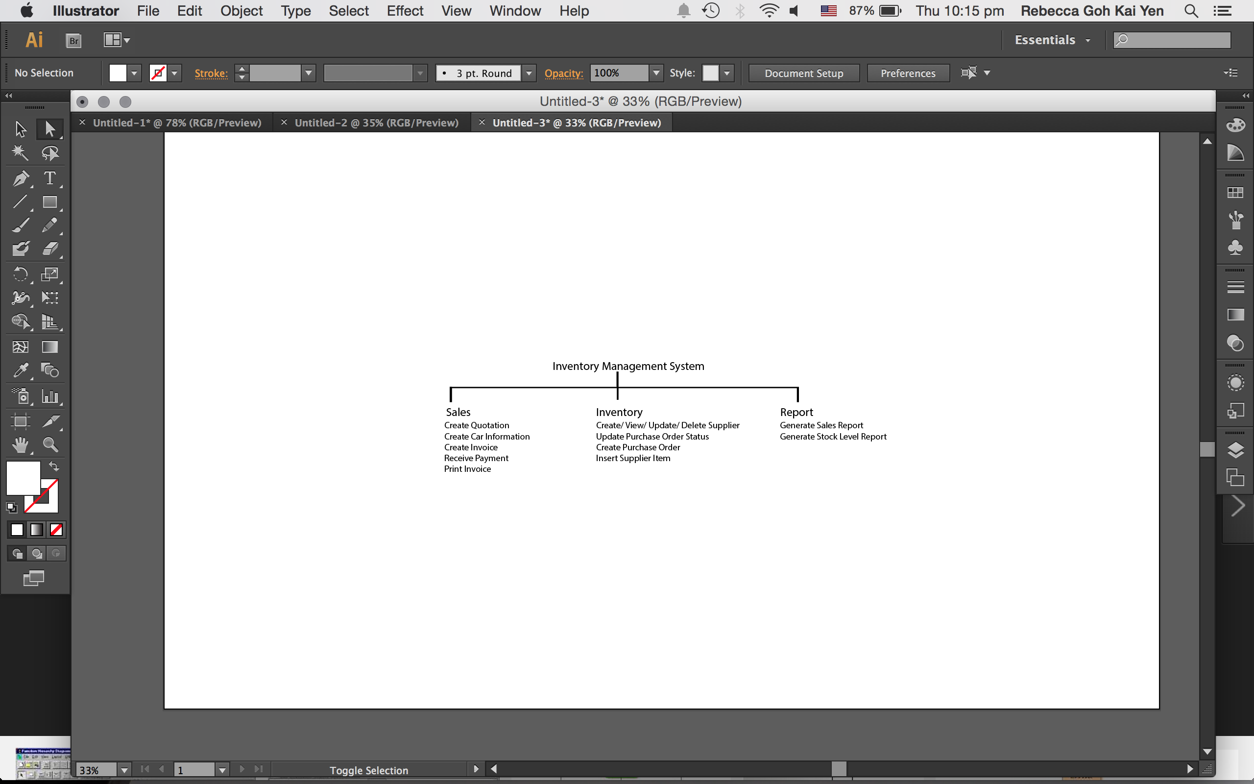

## Summary of Functions

### Sales

1. **Create Quotation**

User can create a quotation under this function and this quotation is printed and given to the customer.

1. **Add New Car Information**

When the new customer comes, our client can add new car information in our system to record about the car that our client is going to repair for the customer.

1. **Create New Customer**

New customer is created every time new customer comes and repairs their vehicles at our client. Customer information is stored in our database and then retrieves back their information when the customer visits our client in the future.

1. **Create Invoice**

Invoice is created under sales section and then it is printed out and given to the customers. Invoice information and the data that has been key in to the invoice is kept in our database as well.

1. **Create Receive Payment from Customer**

Receive payment are created upon receiving the payment from the customers.

1. **Print Invoice**

Invoices are printed using this function. Invoices are printed to keep as a hard copy by both customers and our client.

### Inventory

1. **Create New Supplier Item**

New supplier item or parts are added under this section. All the necessary such as part number and brand name must be filled up before creating a new supplier item.

1. **View Existing Supplier**

This function allows user to view supplier information and contacts.

1. **Create New Supplier**

New suppliers are added using this function. All the necessary information must be filled up before creating a new supplier.

1. **Create Purchase Order**

Purchase order is created under this function and purchase order is created to send the purchase form to the supplier.

1. **Update Existing Purchase Order**

Thin function allows users to update existing purchase order where by PO status is updated. PO status is changed when the goods are received or paid to the suppliers.

### Report

1. **Display Sales Line Graph**

This function allows user to display yearly sales graph. Data are retrieved from the invoice. User can choose which yearly sales they want to display and the graph will be displayed according to the year that user is selected.

1. **Display Inventory Stock Bar graph**

User can display the stock bar graph in this section where inventory stocks level will be displayed in a form of bar graph.

# Operating Environment

## Hardware

Our system supports Windows Vista or Windows 7 and above and it will be able to run on android tablets.

## Software

NetBeans IDE

NetBeans IDE will be used for developing the website for both the desktop/laptop and mobile version. NetBeans itself has error highlighting and debugging functions so it will be easier for us to work with it.

Bootstrap

Bootstrap allows us to easily design a simple yet beautiful website. Less design coding is needed which will greatly save us time and allows us to shift our focus to the functions instead. Bootstrap provides us website templates and we could easily drag new codes to make the necessary changes as well.

## Procedure for configuring server

1. Download and install Easyphp Dev Server 14.1 VC11
2. Import the database file into the MySQL server
3. Import the source codes into the Easyphp project folder
4. Configure the database authentication information
5. Register user into the system
6. Open up the hosting computer’s ip address for connection to the system

# General Procedures & Information

## Sign-on and Sign-off procedure

**Everyday user has to login to the system to start off their day. The repair man would take the job order, quotation with this system. The admin will make, update a purchase order, add new supplier, new supplier parts with the system. Whereas as for the sales department they could take a look at the graphs and make predictions to do things that will help the company increases its revenue. At the end of the day, user have to log out of the system to prevent any misuses of the system.**

## Operating Instructions

User have to on the computer/tablet and connect to the localhost before starting the system. Upon getting in the system, user have to key in their given user and password to access the system. After accessing the system, there will be 3 function.

The sales function is for the repair man, inventory is for the admin and lastly the report is for the sales department

# Function Documentation

## Getting started

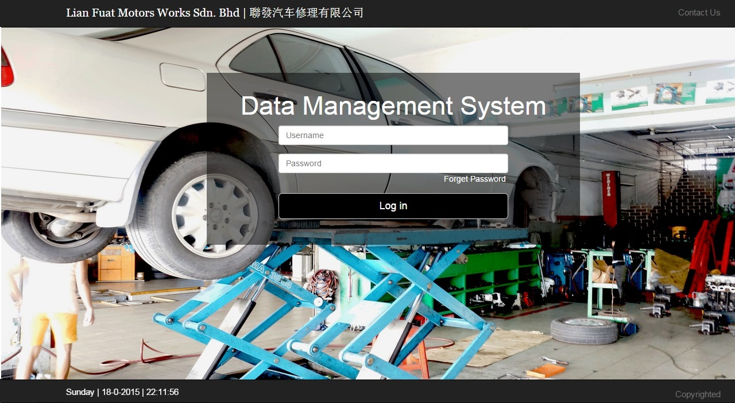

### Logging into system

Product key: Username and Password

1. Enter **Username** and **Password** that we have provided.
2. Click **Log In** button

## Home Page

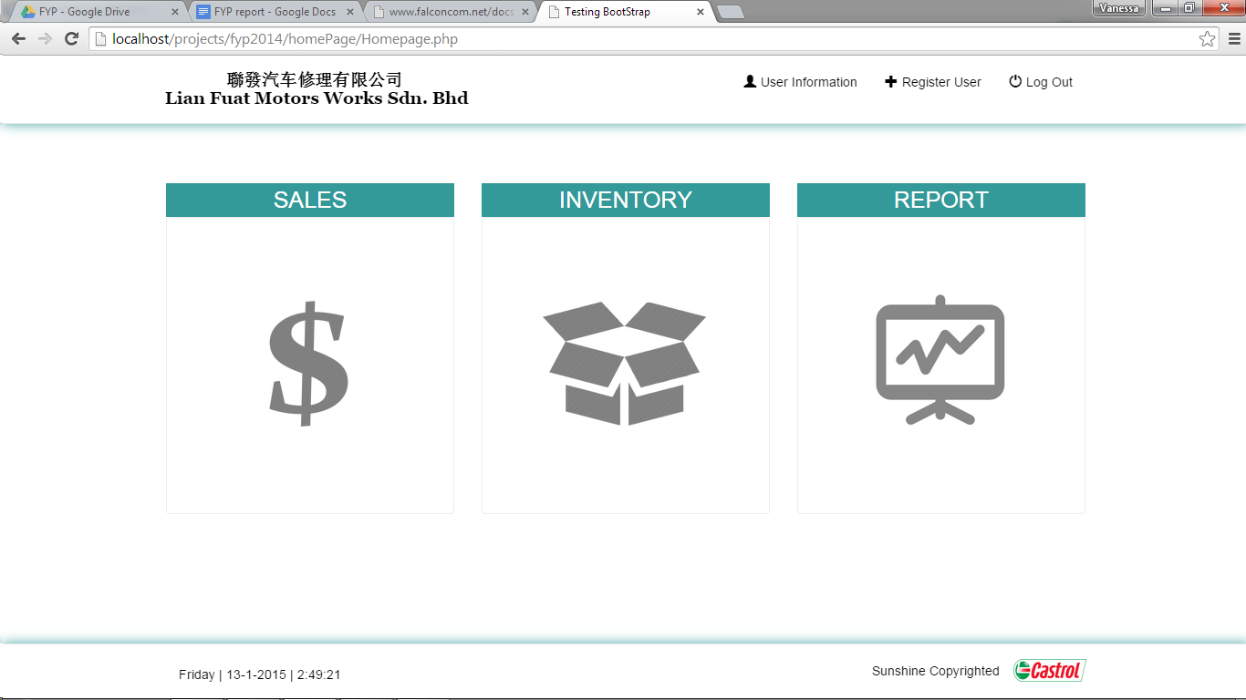

This is the page that user will see after **Logging into system**.

This page features three main functions of our system, such as Sales, Inventory and Report.

User just needs to click on one of the function and it will lead them to the respective pages documented below.

## Sales

This section provides information on the following topics:

• Create/View quotation

Creating quotation enables the user to create a quotation which will be sent to the customers. Under this section, user needs to fill up the quotation form and after that click on ‘submit’ button to send the quotation to customers.

• Create/View invoice

Creating invoice enables the user to create an invoice whenever the customer comes for the repairing services. Create invoice served as billed information to our client’s customers.

• Create/View customer

Whenever the new customer comes to the our client, they have to use this function to add the customer information to the database. So that when the customer comes again, our client just need to retrieve the information from the database.

View customer enables the user to update or edit the customer information. Also, user can see the history of the customer transactions with our client.

• Receive payment

This function enables the user to receive the payment from the customers. All the payments made by customers are recorded in received payment and also update the user payment status. It also stores the payment mode that customer chose.

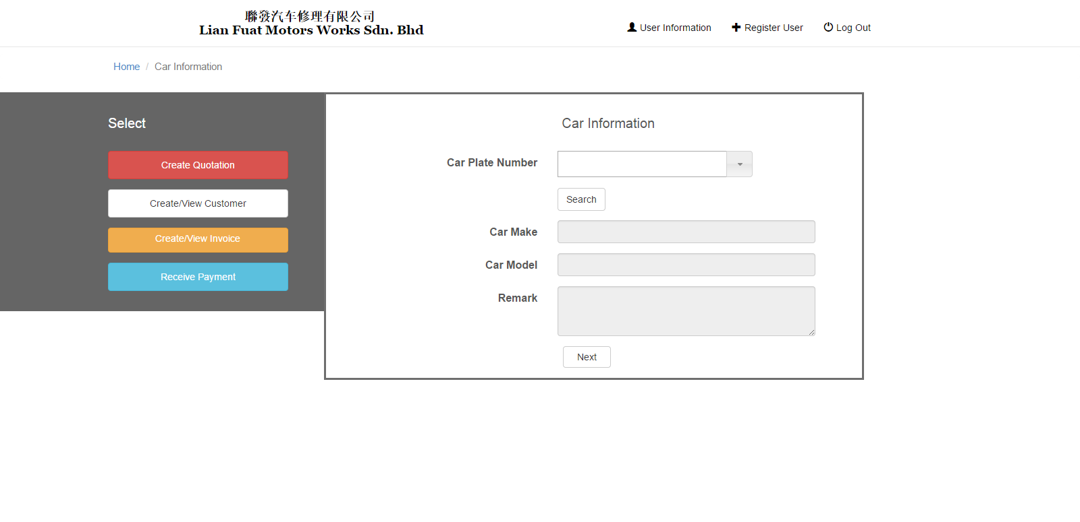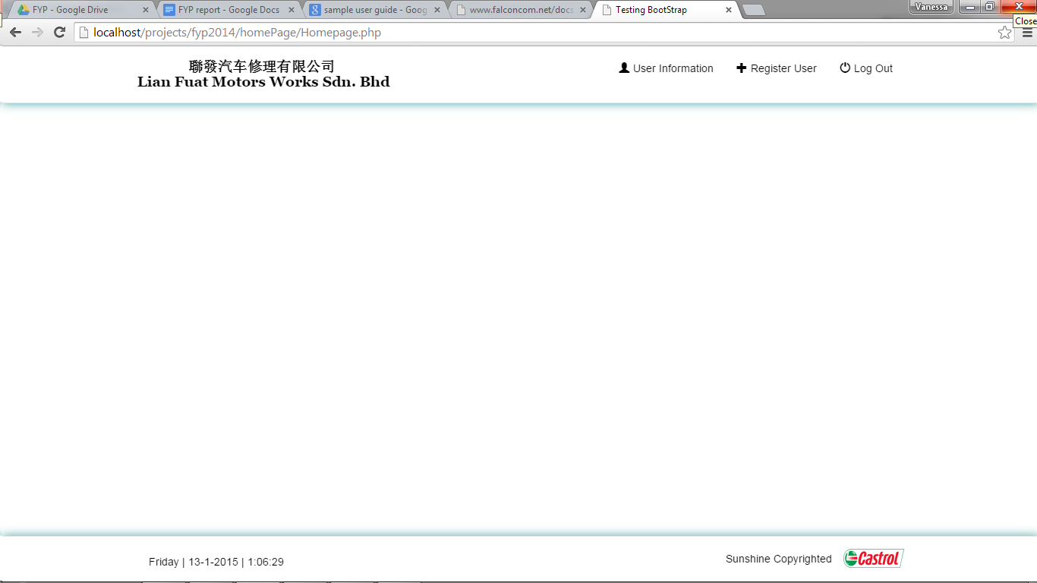

### Create a quotation

1. Click on the **Sales** at the homepage
2. Key in **Car information**
3. Click on the **Next** button
4. Choose the type of services at the **Services**
5. Click **Add** button
6. Fill up the Item, Item Name, Description, Unit Price, Quantity, Line total
7. Click **Submit** button

### Creating New Customer

1. Click on the **Sales** at homepage
2. Click on **Create/View Customer** button
3. Key in the **Car information**
4. Click **Next** button

### View Existing Customer

1. Click on the **Sales** at homepage
2. Click on **Create/View Customer** button
3. Key in the **Car information**
4. Click **Next** button

### Create an Invoice

1. Click on the **Sales** at homepage
2. Click on the **Create/View Invoice button**
3. Key in **Car information**
4. Click **Next** button
5. Fill up the quotation form
6. Click **Done** button
7. Invoice page will be created with the data key in at the quotation page
8. Click **Print** button to print out the invoice

### View an Invoice

1. Click on the **Sales** at homepage
2. Click on the **Create/View Invoice** button
3. Key in **Car information**
4. Click **Next** button
5. Fill up the quotation form
6. Click **Done** button
7. Invoice page will be created with the data key in at the quotation page
8. Click **Print** button to print out the invoice

### Receive Payment

1. Key in **Car plate number** in the search box
2. Click **Search** button
3. Select **Payment Method** from dropdown list
4. Enter **Reference Number**
5. Select **Received By** user from dropdown list
6. Click **Update** button

## Inventory

This section provides information on the following topics:

• New Supplier Item

The new supplier item function enables the user to select the company from a drop down list then allowing user to add any relevant item(s) into the selected supplier.

• Supplier Creation and View

The supplier creation and view function allows the user to create a new supplier, view supplier information, update the relevant details of a supplier and delete a supplier.

• New Purchase Order

The new purchase order function allows the user to create a purchase order by selecting a company from the drop down list then selecting the parts in the particular company in which the user want to order.

• A/P Payment

The A/P payment function enables the user to select the relevant PO and update the PO status to “paid” or “goods received”. If the user selects “paid” for PO status it will only update the status of the PO, basically from “sent” to “paid” else for “goods received” the PO status will be updated from “sent” / “paid” to “goods received” and it will add the relevant ordered parts to the existing parts.

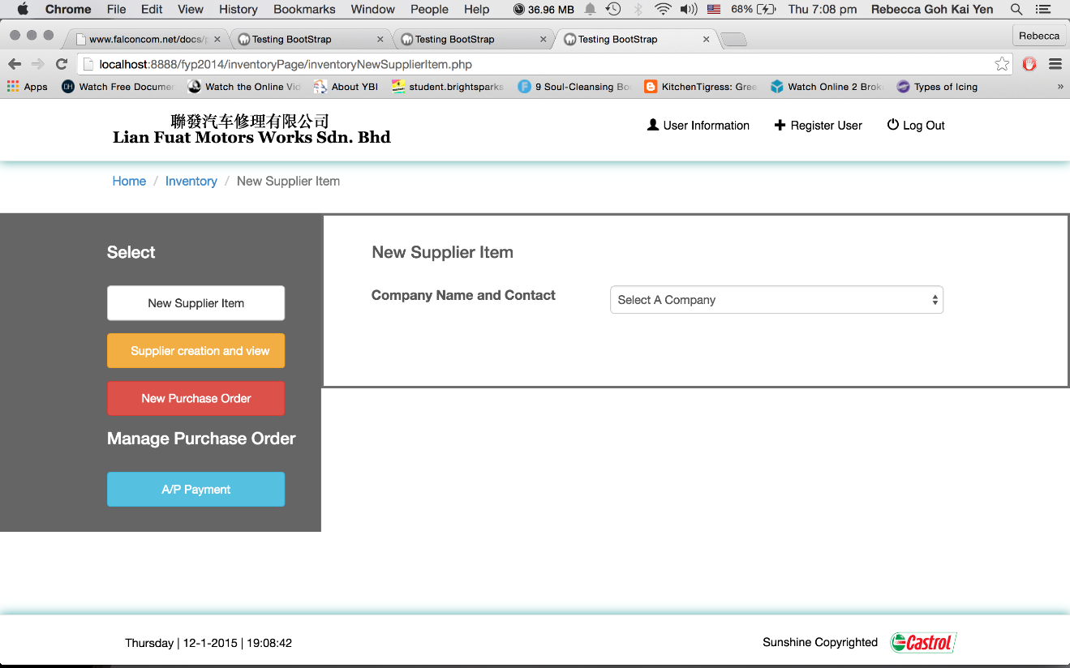

### Create new supplier item

**Note**: User has to enter all fields except remark else user will be prompted.

1. Select **Company** from dropdown list
2. Enter **Part Name** – e.g. Car Panel
3. Enter **Part Number** – e.g. Panel 23- 51-5
4. Enter **Brand** – e.g. Mitsubishi
5. Enter **Part Description** – e.g. make of 99 percent alloy. Extremely durable

*Note –* ***Part Quantity*** *is 0 by default*

1. Enter **Cost Price** – e.g. 50.32
2. Enter **Retail Price** – e.g. 89.20

*Note* ***– Stock Level*** *is 0 by default &* ***Stock Status*** *is “Re-order” by default*

1. Enter **Remark** *(Optional)* – e.g. High in demand causing fast depletion of this part stock level
2. Click **Submit** button

### Supplier Creation and View

This section provides information on the following topics:

* + Create a supplier
  + View a supplier
  + Update a supplier
  + Delete a supplier

**Note**: User has to enter all fields except remark else user will be prompt.

To create a new supplier:

1. Click **New** button
2. Enter **First Name** – e.g. Tony
3. Enter **Last Name** – e.g. Tan
4. Enter **Office Contact** – e.g. 612534678
5. Enter **HP contact** – e.g. 93456784
6. Enter **Fax Contact** – e.g. 62341235
7. Enter **Address** – e.g. Bukit Panjang street 4, Blk 42 (Line 1)  
    #06-52(Line 2)  
    S543215(Line 3)
8. Enter **Company Name** – **e.g. Aftermarket Pte Ltd**
9. Enter **Remark** *(Optional)* – e.g. lowest price offered for automobile parts in this region.
10. Click **Submit** button

To view a supplier:

1. Select the **Company** from the drop down list

To update an existing supplier information:

1. Select the **Company** from the drop down list
2. Look for the relevant fields to update
3. Click **Update** button

To delete an existing supplier:

1. Select the **Company** from the drop down list
2. Click **Delete** button located at the bottom of the page

### New purchase order

Note: User has to enter all fields except remark else user will be prompt.  
To create a new purchase order:

1. Select the **company**

*Note –* ***Date of Creation*** *is ‘today’ date by default, PO status is sent by default*

1. Enter your name for **Order By** – e.g. Rebecca Goh
2. Enter **Remark** *(Optional)* – e.g. Ambiguous Purchase Order.
3. Select **item** to order by ticking the checkbox
4. Click **next** button
5. Enter the **part quantity** to order – e.g. 1
6. Click **submit** button

### A/P Payment

To update an existing purchase order:

1. Select the **PO No. | D.O.C | Order by**
2. Select the **PO status** e.g. “paid” / “goods received “
3. Enter **Remark** *(Optional)* – e.g. Ambiguous Purchase Order.
4. Click **Update** button

## Report

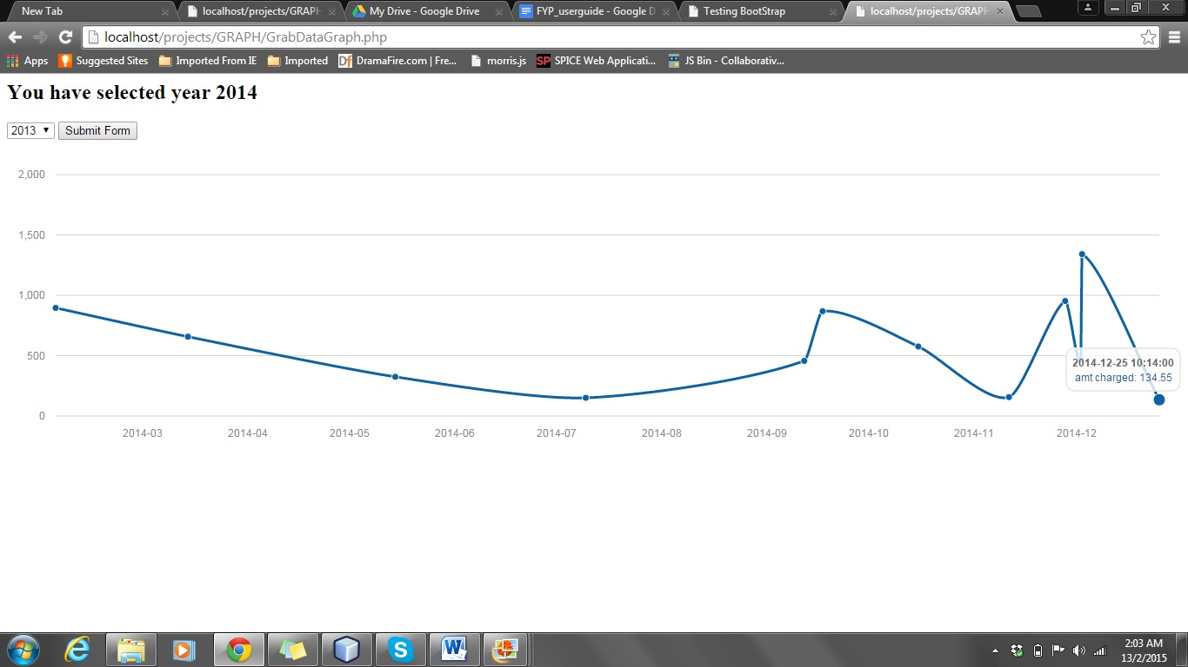

### Sales Graph

To display the sales graph

1. Click on the **Report** at homepage
2. Click on **Sales**
3. Select the **year** from the dropdown list
4. Click on **Submit Form** button

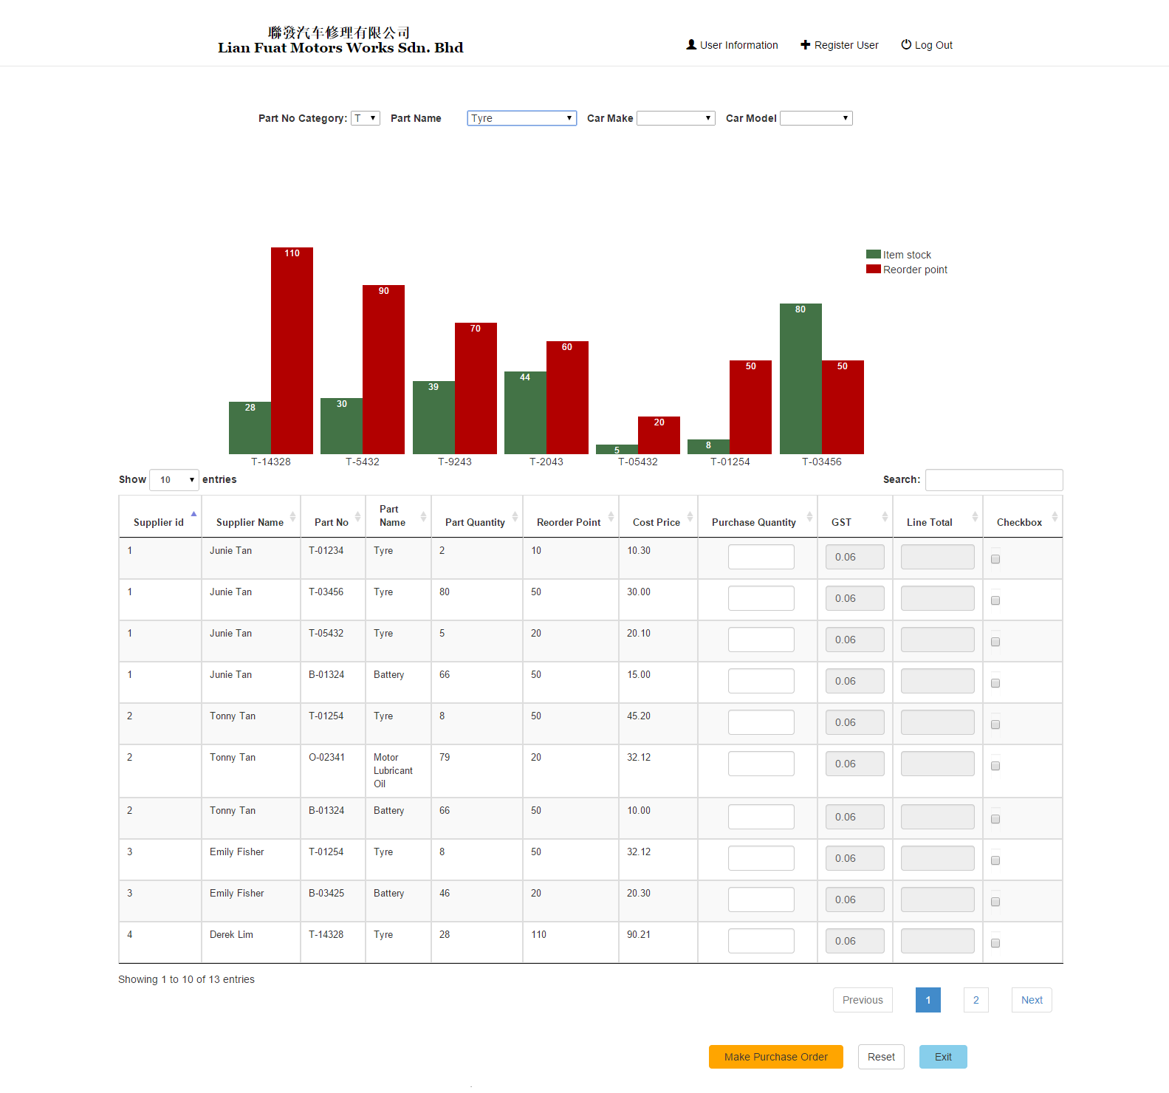

### Sales Graph

To display bar graph:

1. Select one of the filtering dropdown menus namely **Part No Category**, **Part Name**, **Car Make** and **Car Model.**

Create Purchase Order:

1. ­Toggle on the **Part No column** sorting icon. (Compare price of part no offered by different suppliers to compare and select lowest price)
2. Check on **checkbox column** to order part from supplier.
3. Click on **Make Purchase Order**.
4. Edit necessary input text fields namely **Company Name and Contact, Date of Creation, PO Status, Order By, Remark**.
5. Click on **Submit**.

Create Additional Purchase Order:

1. Click on Reset to reset the input text fields namely Purchase Quantity, and check box from previous purchase order.
2. Repeat step 1 to step 5.

# Complete list of test data

### Customer Invoice Table

### User Table

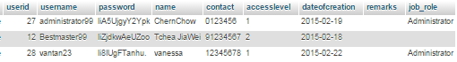

### Customer Table

